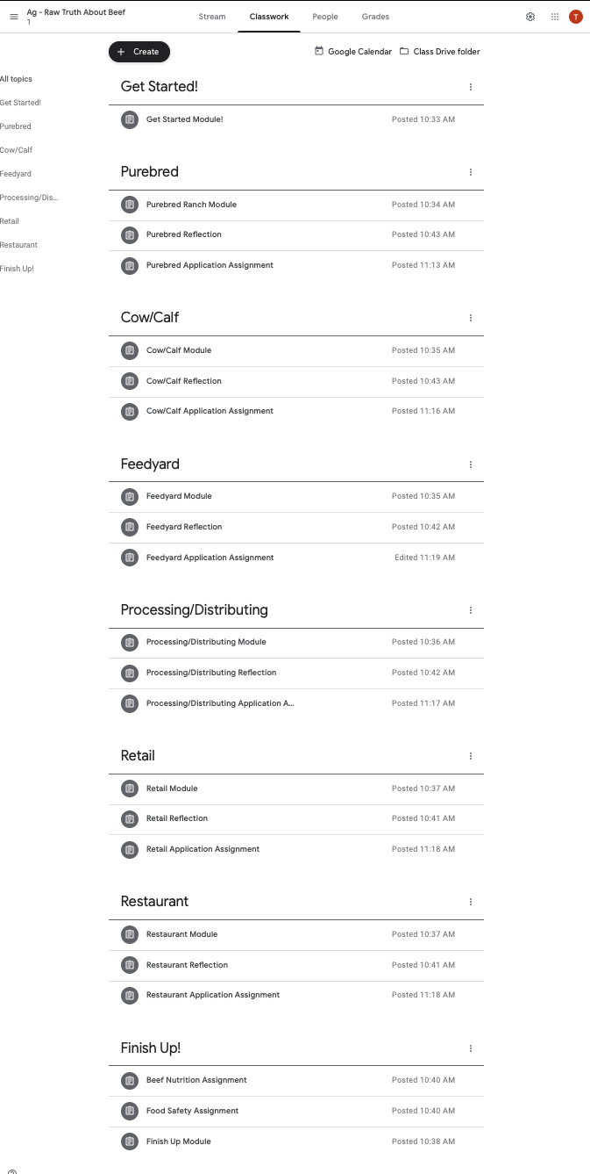

Your final course will look like this. Use the “+ Create” button to create each topic and assignment.

Module Assignments
Create all Module assignments as ungraded. Add the title, copy the instruction text, select the correct topic, add the link to the module, and assign.
- Getting Started Module:
  - Instruction text: Follow the link to the first module. Watch the promo video to see what you're getting into! Answer the questions in the survey, then meet the cast.
  - Link: https://rise.articulate.com/share/IiLKG2JfuPW8_gW1hf9siKbP-XGFAI1s
- Main Modules:
  - Instruction text: Follow the link and click start course. Watch the videos, explore the 360 experiences. Check out the attached resources.
  - Purebred Link: https://rise.articulate.com/share/iS2I9GiIFxgWXjZd4mBcptMQdA-e8e1J
  - Cow/Calf Link: https://rise.articulate.com/share/R7oYtS3-nsv9e3qjc2xdC85qF5iipKBz
  - Feedyard Link: https://rise.articulate.com/share/QuML9eCXLXuE4K6wvQ-7CFqXCR7Ovcin
  - Processing/Distributor Link: https://rise.articulate.com/share/4fp8Y1gCZ6w1-gdTpIGZ6be1rbiJazkC
  - Retail Link: https://rise.articulate.com/share/e6U4H7AoKucRe1WWcj1xQj-j-gtCukWW
  - Restaurant Link: https://rise.articulate.com/share/Tvc9fgW6aot8BrfQAy-t_FMt06plWPJu
- Finish Up Module:
  - Instruction text: Check out the in-depth resources and explore anything that looks interesting to you! Finish up by completing the survey.
  - Link: https://rise.articulate.com/share/wKfTL-3h8rJqqmBSs3pKwkclKa2yx1KQ

Reflection Assignments
Create all reflection question assignments as graded. Add the title, copy the instruction text, select the correct topic, and assign.
- Instruction Text: Answer the following reflection questions. Submit your assignment as a GoogleDoc. (Copy the appropriate questions below as part of the instruction text).
- Purebred:
  - What made you curious as you explored the purebred ranch?
  - How is beef quality and consistency influenced by cattle genetics?
  - What role does technology play in purebred ranchers’ ability to improve the genetic potential of their herds?
  - Of the information covered in this segment, what do you see as most important to understand for your future career?
- Cow/Calf:
  - What surprised you about what you learned?
  - Describe how beef cattle upcycle grass and convert it into animal protein.
  - Why are animal identification systems important for tracking animal health?
  - What best practices do beef producers employ when using antibiotics and giving vaccines?
  - How can you apply the learning from this segment into your interactions with peers or others curious about beef production?
- Feedyard:
  - What were the most important elements or significant ideas presented at the feedyard?
  - How do different feed rations affect the tenderness and flavor of beef?
  - List a few common ingredients in feed rations and identify the nutrients they provide the animal. Consider how feed rations are similar to the diets of humans.
  - What information learned in this segment do you see yourself actively applying in your future career?
- Processing/Distribution Facility:
  - What protocols in a processing facility ensure food safety?
  - How have trimming practices changed and how have these changes influenced the fat content of beef?
  - List three to five lean cuts of beef.
  - How do you see yourself applying the information learned in this segment into your career?
- Retail:
  - What information from this segment would you share with your peers or community?
  - What meat handling tips and food safety practices are important for people to understand?
  - What information would you share with your peers about labeling claims on beef products in the meat case?
  - What information learned in this segment do you see yourself using to perform your job well in the future?
- Restaurant:
  - What information surprised you most from this segment?
  - What are two key pieces of advice you would give to someone related to dining out?
  - List five key nutrients that beef provides and one physiological function of each.
  - What information learned from this segment gets you most excited about your future career?

Application Assignments
Create all application assignments as graded. Add the title, copy the instruction text, link the appropriate PDF, select the correct topic, and assign.
- Instruction Text: Download the instructions and additional resources. Submit your assignment as a GoogleDoc.
- PDF Downloads: Download the PDFs individually from Dropbox (below). Or gain access to all of them in Dropbox here. Or through GoogleDrive here.
  - Purebred PDF
  - Cow/Calf PDF
  - Feedyard PDF
  - Processing/Distribution PDF
  - Retail PDF
  - Restaurant PDF
  - Beef Nutrition
  - Food Safety PDF
Standards:
Download the TEKS Standards alignment and PDF of resources in Dropbox here. Or through GoogleDrive here.

